**Learning Report of**

**Academic English Writing**

Name: 韩昊辰

SID: 20214272

Class: 001

Teacher: 张梅

Week: 2

Date: 2023/3/5

# Task 1: My learning

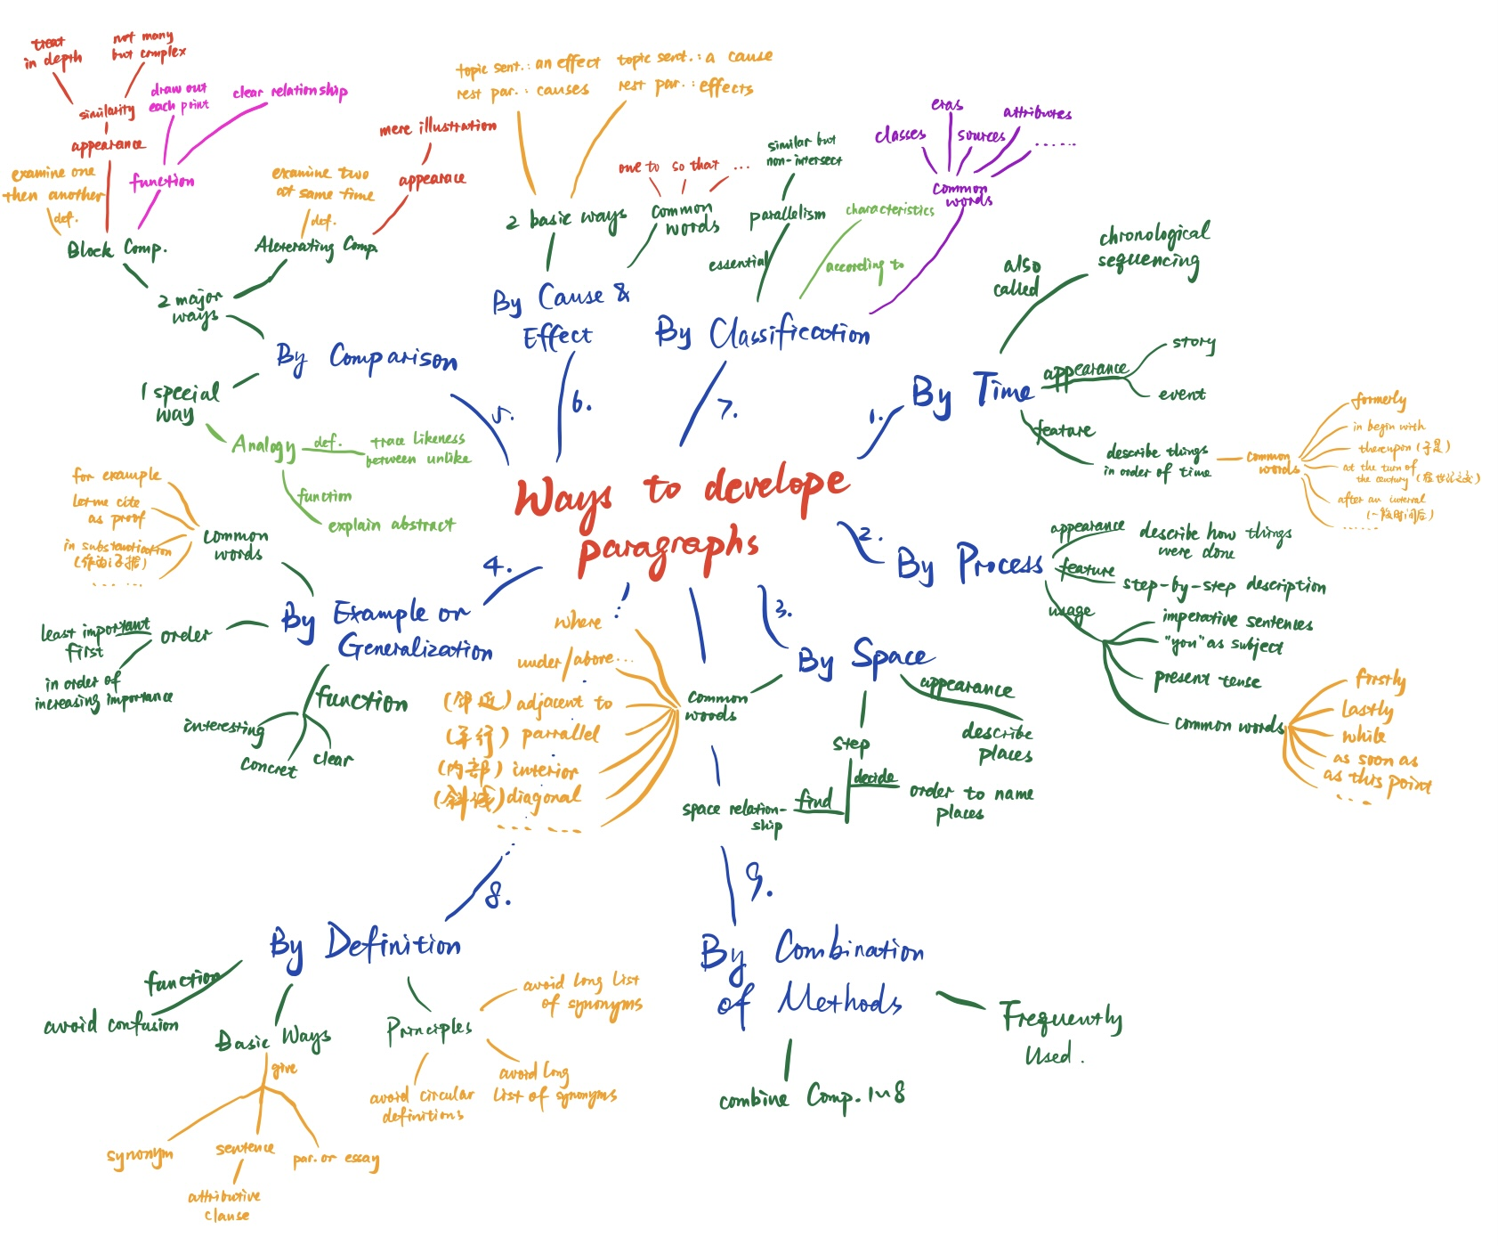**1, Mind map of “Ways to develop paragraphs”**

**2, Mind map of “The Whole Composition”**

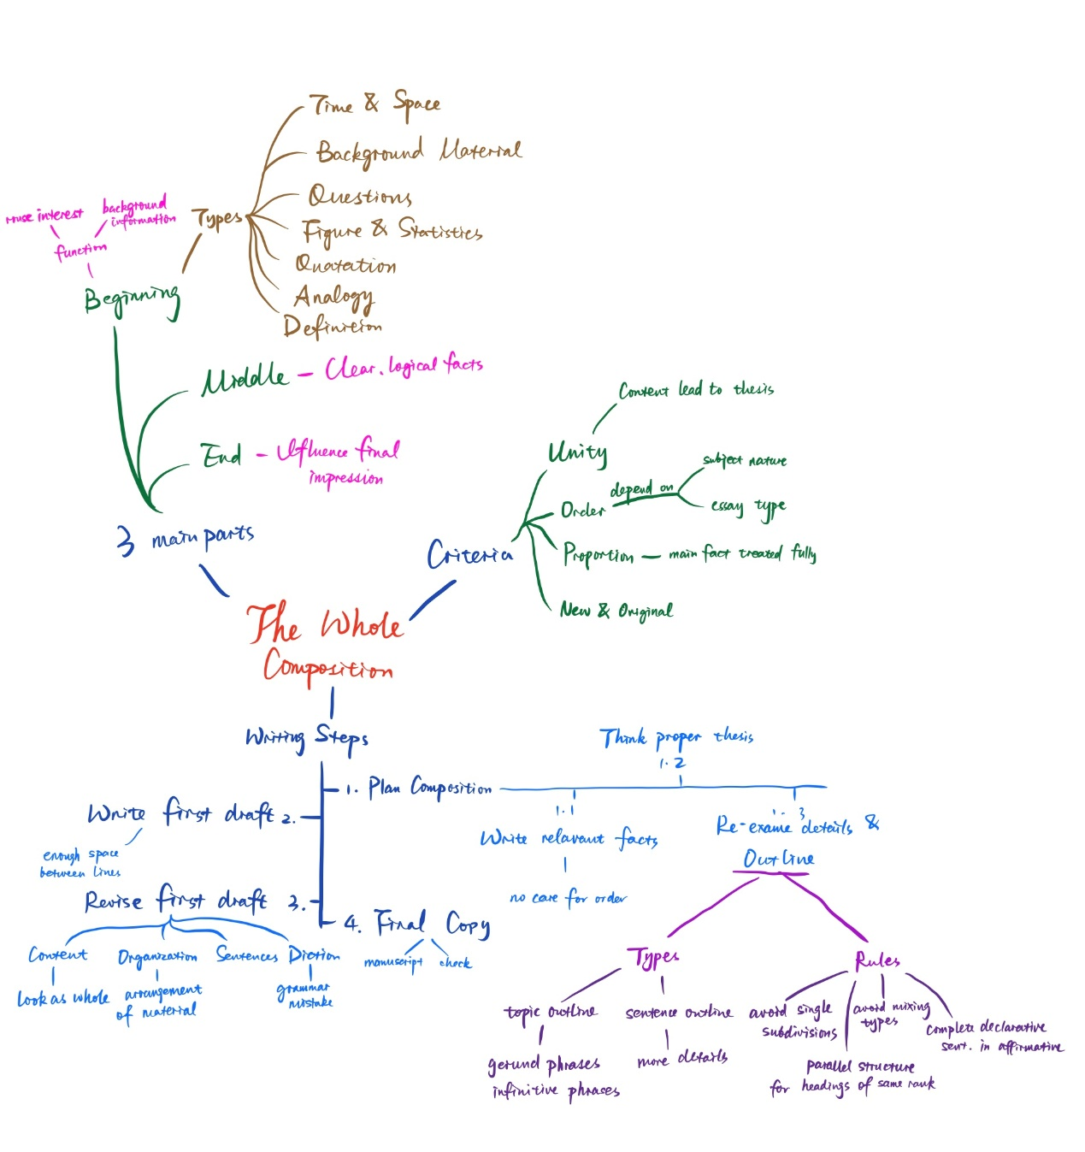

# Task 2: Learning outcomes

* **Ways to develop paragraphs**

1. Highlight the key points of the statement;
2. Make the article more logical;
3. Different ways to develop paragraphs help us apply to different article types and statements.

* **The whole composition**

1. Help us grasp the overall context of the article to make it more unified and complete;
2. It helps to refine our writing process and make our writing more efficient;
3. It allows us to objectively evaluate our articles, find out the problems in our own articles and modify them;
4. It allows us to read others' articles in a more organized way and improve our reading efficiency.